## Abstract

Talav immigration is a comprehensive digital platform available on any device(phone, tablet, computer…) that integrates travel and immigration services into a user-friendly system. This project was developed to address the fragmentation prevalent in current travel and immigration platforms, where users must navigate between multiple websites for booking, visa applications, and information retrieval. The lack of integration often leads to inefficiencies, frustration, and errors. By employing advanced technologies such as WordPress, plugins, and APIs, Talav immigration streamlines these processes to provide unified experience for international travelers.

The platform aims to enhance accessibility, reduce time and effort, and simplify complex processes associated with immigration and travel planning. Drawing upon principles of human-computer interaction, system interoperability, and scalability, Talav immigration ensures that the diverse needs of users are met effectively. This report outlines the theoretical and practical foundations of the platform, including a review of relevant literature, analysis of existing tools and systems, and the rationale behind its design and functionality. Through this innovative approach, Talav immigration positions itself as a transformative solution in the realm of travel and immigration technology.

## Contents

Abstract i

Contents ii

Chapter I Introduction 1

1.1 Introduction 2

1.2 Motivation and background 3

1.3 Problem statement 3

1.4 Key Objectives 4

1.5 Structure of the Thesis 4

Chapter II Theoretical Foundations 5

2.1 Theoritical Foundations 6

2.2 Literature Review 6

2.3 Previous Work 7

2.4 Conceptual Frameworks 7

Chapter III Technical Design and Build 8

3.1 Technical Design and build 9

3.2 System Design Approach 9

3.3 Chosen Tools and Technologies 9

3.4 Website Structure and Implementation 10

Chapter IV Evaluation and Discussion of the System 15

4.1 Evaluation and Discussion of the System 16

4.2 Evaluation Methods 16

4.3 Testing the System 16

4.4 User Feedback 17

4.5 Performance Analysis 17

4.6 Discussion of Findings 17

4.7 Limitations 18

Chapter V Conclusions and Future Directions 19

5.1 Conclusions and Future Directions 20

5.2 Summary of Findings 20

5.3 Conclusions 21

5.4 Suggestions for Future Improvements and Directions 21

**List of Figures**

Figure 1 Homepage 10

Figure 2 Immigration page about USA 11

Figure 3 Study abroad page about Canada 11

Figure 4 Talav form 12

Figure 5 Talav booking form 12

Figure 6 Form detail on admin panel 13

Figure 7 Contact us page 13

Figure 8 About us page 14

Figure 9 Footer of website 14

# Chapter I Introduction

## 1.1 Introduction

In the modern world, the travel and immigration sectors are expanding rapidly, with people seeking better opportunities, experiences, and lifestyles across borders. Navigating this complex space requires efficient, user-friendly platforms that simplify travel booking, visa processing, and integration into new countries. Talav immigration, an innovative web-based platform, was developed with these needs in mind. Built using WordPress, complemented with various plugins, forms, and APIs, Talav immigration offers a unified solution to help individuals plan their international journeys and manage immigration processes.

Traveling and immigration have always been integral parts of human progress, enabling cultural exchange, economic growth, and personal exploration. However, the processes involved can be tedious and fraught with challenges. From searching for accommodations and securing travel bookings to navigating complex visa procedures, individuals frequently face obstacles that disrupt their plans. Addressing these issues requires a solution that consolidates travel and immigration services into an accessible digital platform. Talav immigration aspires to be that solution.

At its core, Talav immigration simplifies the planning and execution of travel and immigration activities. Whether for business or leisure, the platform integrates bookings with visa and immigration support, allowing users to manage everything in one place. Through seamless form-based data entry, automated back-end processes, and intuitive navigation, the platform provides an engaging and functional experience for cross-border travelers.

Moreover, Talav immigration addresses a key market gap: balancing user convenience with accurate, up-to-date information. Immigration laws, travel restrictions, and entry requirements frequently change, creating confusion among travelers. By leveraging real-time API integrations and adaptable forms, Talav immigration ensures that users receive the latest guidance. This builds trust and reduces the likelihood of errors that could jeopardize travel plans.

The flexibility offered by WordPress played a crucial role in creating Talav immigration. Its extensive plugin ecosystem enabled secure payment systems, advanced search functionality, and responsive design elements, ensuring accessibility on desktop and mobile devices. This scalability and adaptability align with the dynamic nature of travel and immigration, making Talav immigration a forward-thinking solution for a global audience.

In an increasingly globalized world, the demand for platforms like Talav immigration continues to grow. People from all walks of life—students, professionals, tourists, and families—seek reliable tools to manage their travel and immigration needs efficiently. By providing a centralized platform catering to these diverse requirements, Talav immigration streamlines the user experience while fostering security and preparedness. Through its innovative use of technology, the platform represents the future of digital solutions in travel and immigration.

## **1.2 Motivation and background**

Traveling to a new country can be a complex process, involving various stages such as accommodation reservations, visa applications, travel insurance, and navigating unfamiliar governmental processes. Talav immigration emerged as a response to this complexity, providing a central hub for all immigration and travel needs in one easy-to-navigate platform. The development of this platform was motivated by the challenges and inconveniences faced by individuals when managing travel and immigration on multiple platforms, often requiring input and coordination from various service providers.

Through user feedback, market research, and an in-depth understanding of industry-specific issues, it became clear that a unified digital space could greatly enhance the efficiency and ease of travel planning. The website’s goal is to offer users a seamless experience where multiple needs are met simultaneously, from booking flights and accommodations to submitting forms for visa approval.

Building on the flexibility of WordPress and its powerful suite of plugins, the platform was designed with scalability and user adaptability in mind. This not only catered to travelers' practical needs but also addressed the importance of providing transparency in the immigration process, which is often shrouded in complexity. By leveraging technologies like API integrations for real-time updates, Talav immigration stays up-to-date with changing rules and guidelines from immigration authorities, creating an optimal environment for stress-free travel preparation.

## **1.3 Problem statement**

Despite advancements in the digitalization of travel and immigration services, many existing platforms lack necessary integration, user-friendliness, and centralized solutions for efficient planning and execution. The challenge lies in the fragmented approach towards these services, requiring users to navigate multiple websites and providers. Submitting complex forms, such as visa applications, and the absence of real-time updates create unnecessary stress for travelers.

Additionally, current platforms often fail to meet the comprehensive needs of international travelers. Some focus solely on accommodation bookings, while others provide incomplete immigration solutions without ensuring a smooth user experience. Users frequently encounter poorly integrated systems, resulting in frustration and inefficiency.

**Identified Challenges**

1. Navigating complex immigration laws and procedures is overwhelming due to legal intricacies and ever-changing policies.
2. A lack of accessible, understandable resources, especially for individuals without prior knowledge or access to legal services.
3. Fragmented systems leading to user frustration and inefficient planning processes.

## **1.4 Key Objectives**

The main objectives behind developing the Talav immigration platform are as follows:

1. **Provide a One-Stop Solution for Travel and Immigration**: Allow users to manage the complexities of travel, accommodation, and immigration procedures in a centralized platform.
2. **Ease of Use**: Ensure that users find the platform simple and intuitive, especially when filling out booking forms, submitting immigration-related documents, and tracking applications.
3. **Real-Time Updates**: Integrate APIs and other technologies to provide real-time information and updates to users, keeping them informed about changes in immigration laws and travel-related processes.
4. **Seamless User Experience**: Design a responsive and easy-to-navigate platform with clear, step-by-step guidance for every part of the travel and immigration journey.
5. **Incorporate Automation**: Incorporate automated forms and processes to reduce human errors, speed up submissions, and track progress in visa applications or bookings.
6. **Transparency and Trust**: Build a transparent system for visa and accommodation bookings, with regular tracking of forms and progress.

1.5 Structure of the Thesis

This document is structured into five chapters that guide the reader through the full scope of the Talav immigration project, from initial concepts to system evaluation and final insights.

* **Chapter I: Introduction** => Introduces the Talav immigration website, outlines its purpose, goals, and the challenges it seeks to address, and presents the overall structure of the thesis.
* **Chapter II: Theoretical Foundations** => Reviews relevant literature and existing technologies in travel and immigration, identifies current system gaps, and highlights frameworks that support the project’s approach.
* **Chapter III: Technical Design and Build** => Summarizes the system’s design approach, chosen tools, and development process, focusing on how the website was structured and implemented.
* **Chapter IV: Evaluation and Discussion of the System** => This chapter provides a focused evaluation of the system, including testing, user feedback & performance analysis. It examines how well the website meets its objectives & discusses results, highlighting strengths, addressing limitations.
* **Chapter V: Conclusions & Future Directions** => Provides a summary of findings, concludes the work, and offers suggestions for future improvements and directions.

# Chapter II Theoretical Foundations

## 2.1 Theoritical Foundations

Understanding the theoretical underpinnings of Talav immigration is crucial for its development and implementation. This chapter explores the evolution of digital platforms in the fields of travel and immigration, reviews existing literature, and examines previous systems that inspired the creation of Talav immigration. In a world where technology has revolutionized almost every sector, there remains a noticeable gap in integrating travel and immigration services into a single, user-friendly framework. By analyzing various studies, platforms, and technological trends, this chapter highlights these gaps and establishes how Talav immigration aims to address them effectively. The chapter also delves into theoretical frameworks that support the conceptualization of this platform, paving the way for its practical implementation.

## 2.2 Literature Review

Digital advancements have had a profound impact on travel and immigration services, with numerous platforms emerging to simplify various aspects of these processes. However, studies show persistent shortcomings that affect the efficiency and accessibility of these services. For example, one study analyzed the user experience in travel booking platforms and found that fragmented services lead to inefficiencies and increased stress for users [1]. The researchers noted that integrating services like accommodation, transportation, and visa processing would significantly enhance the user experience.

Another investigation into digital tools in immigration processes emphasized the importance of real-time information and seamless automation [2]. It highlighted challenges related to outdated data and confusing user interfaces, which hinder platform success. This work underscores the need for centralized, accessible systems capable of adapting to regulatory changes and providing up-to-date guidance.

Further research into the evolution of travel booking systems, focusing on platforms like Booking.com and Skyscanner, showed these platforms excel at simplifying accommodation and transport bookings but largely ignore immigration requirements [3]. This narrow focus limits their utility for international travelers needing comprehensive solutions.

Meanwhile, websites such as Visatronix and Path2USA specialize in immigration assistance but lack integration with travel services like flights and hotels. The fragmentation creates hurdles for users, often leading to inefficient planning [4].

Talav immigration was conceived to address these shortcomings by consolidating travel and immigration services into a single, unified platform. This integration simplifies the planning process and ensures accuracy, efficiency, and accessibility for users worldwide.

## 2.3 Previous Work

Talav immigration builds upon the successes and learns from the limitations of several existing systems:

1. **Travel Booking Platforms**: Platforms like Expedia, Booking.com, and TripAdvisor have revolutionized how travelers plan trips. They offer vast options for accommodation, transport, and tours. However, their scope is limited, leaving users to handle immigration and visa-related tasks separately. This segmentation often results in inefficient planning and added user stress [5].
2. **Immigration Assistance Platforms**: Services like iVisa and Path2USA focus solely on immigration-related tasks such as visa applications and document guidance. But they lack travel booking functionalities, forcing users to manage multiple platforms to complete travel plans [4].
3. **Attempts at Integrated Systems**: Some startups have tried offering combined travel and immigration solutions, but these attempts often face scalability issues and struggle with outdated technologies and dynamic immigration laws [6].

By studying these systems, *Talav immigration* incorporates their strengths while addressing their weaknesses. The platform uses modern tools like WordPress, advanced plugins, and APIs to create a scalable, adaptable solution that meets the diverse needs of international travelers.

## 2.4 Conceptual Frameworks

The development of Talav immigration is grounded in several conceptual frameworks that guide its design and functionality:

1. **Human-Computer Interaction (HCI)**: This framework emphasizes the need for intuitive interfaces and automation to improve user experiences. By reducing cognitive load and automating tasks like form submissions and real-time updates, Talav immigration ensures a smooth user journey [7].
2. **System Interoperability**: This framework highlights the necessity of creating interoperable systems that allow different digital services to function cohesively. Talav immigration achieves this through API integrations linking travel bookings, immigration processes, and payment systems [8].
3. **Task Simplification**: This framework involves centralizing multiple services under one roof to reduce the number of steps required to complete tasks, saving users time and effort [7].
4. **Adaptability and Scalability**: This framework stresses the importance of evolving systems that adapt to changing user needs and external environments. Talav immigration embraces modular design and real-time updates to remain relevant and reliable [9].

Through these conceptual frameworks, Talav immigration stands as a user-centric platform that bridges the gap between travel and immigration services.

# Chapter III Technical Design and Build

## 3.1 Technical Design and build

This chapter outlines the technical blueprint and the steps taken to create the Talav immigration website. This platform is specifically designed to guide and inform people, especially those from Kurdistan, who are seeking opportunities for immigration and studying abroad. The website provides in-depth information about various destination countries, covering the necessary procedures, associated costs, and eligibility requirements for different pathways such as education, investment, permanent residency, and seeking asylum.

## 3.2 System Design Approach

The Talav immigration website was built using WordPress, a user-friendly content management system (CMS). This platform was chosen for its ease of use in managing website content, the availability of numerous plugins to add extra features, and the extensive support available online. The main goal of the design was to create a website that is easy to navigate and provides clear, detailed information. This allows users to quickly find the specific details relevant to their immigration or study abroad aspirations. The website is tailored to the needs of the Kurdish community, keeping in mind their specific circumstances and requirements related to international migration.

## 3.3 Chosen Tools and Technologies

The creation of the Talav immigration website involved the use of several important tools and technologies, all implemented by a single developer:

* **WordPress:** This served as the core foundation of the website. It manages all the content, user accounts, and the overall functionality of the site. The WordPress admin area (wp-admin) is where all the website content and settings are managed.
* **XAMPP:** This local server environment was used as a testing ground during the website's development. It provided the necessary components like the Apache web server, the MySQL database, and the PHP interpreter to run WordPress on a local computer. The website's data, including all the text, user information, and plugin settings, is stored and organized in the MySQL database.
* **Elementor:** This is a very important plugin that allowed for the visual design and layout of the website's pages. It made it possible to create attractive and interactive pages without needing to write complex code.
* **Elementor Header & Footer Builder:** This plugin was used to create a consistent and informative footer at the bottom of every page, containing important details and quick links.
* **Metform:** This plugin was used to build and manage the two key forms on the website: the "Talav Form" for general immigration inquiries and the "Booking Form" for scheduling meetings. This plugin handles the information submitted by users in both English and Kurdish.
* **Smart Slider:** On the homepage, this plugin was used to create a visually appealing slideshow to highlight important information and guide users to different parts of the website.
* **Safe Layout Cute Preloader:** This plugin adds a loading animation that displays the website's logo while the page is loading, providing a smoother initial experience for visitors.
* **WP-Optimize:** This plugin was used to make the website faster and more efficient by cleaning up the database, compressing images to reduce their file size, and using caching techniques.
* **Blocksy Theme Companion:** This plugin added extra features and options that work with the chosen Blocksy theme, allowing for more customization and a consistent design.
* **All-in-One WP Migration:** This plugin was crucial for creating backup copies of the entire website, including all the content, files, and settings. This ensures that the website can be easily restored if any issues occur.

## 3.4 Website Structure and Implementation

The Talav immigration website is organized into several key sections, each designed to serve a specific purpose and provide targeted information:

* **Home:** This is the main page of the website and acts as a starting point for users. It provides a summary of all the different types of information available on the site, with links to sections on immigration, studying abroad, and the forms. (see figure 1)

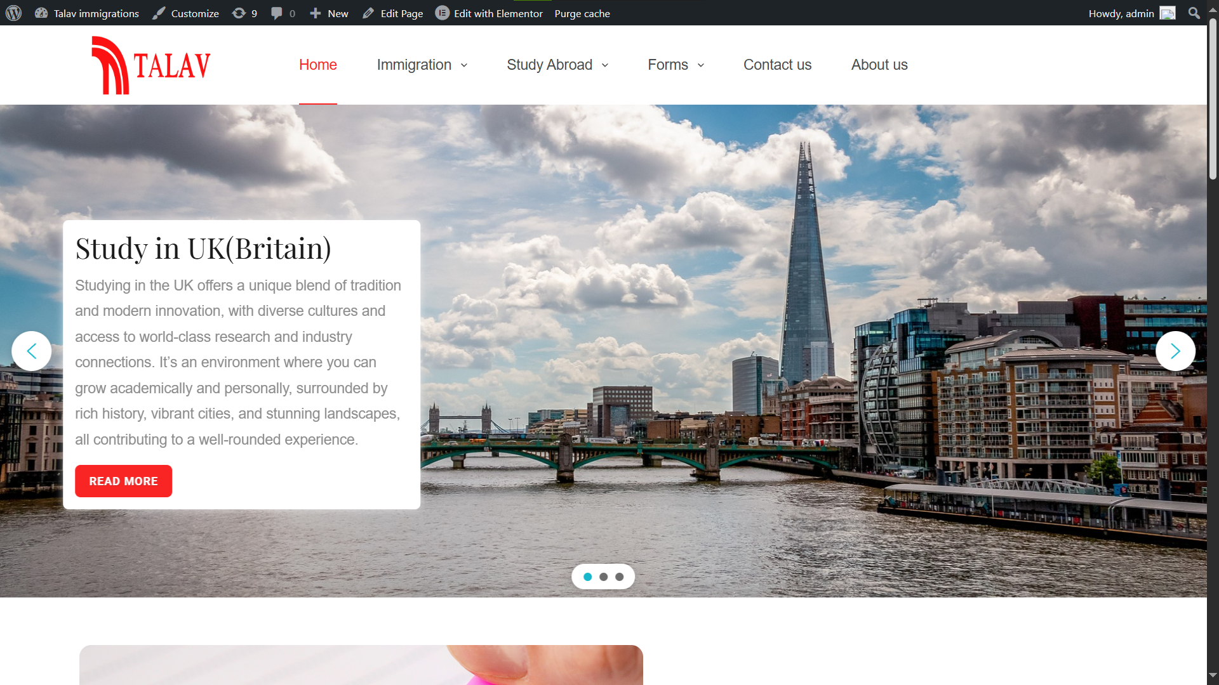

Figure Homepage

* **Immigration:** This section provides detailed information about immigrating to eight different countries that consist of (America, Britain, Canada, Australia, Germany, Netherlands, Austria & France), For each country, it explains who is eligible to immigrate, the costs involved, whether it's possible to go for education, investment, permanent residency, or asylum, and includes answers to common questions and helpful advice. (see figure 2)

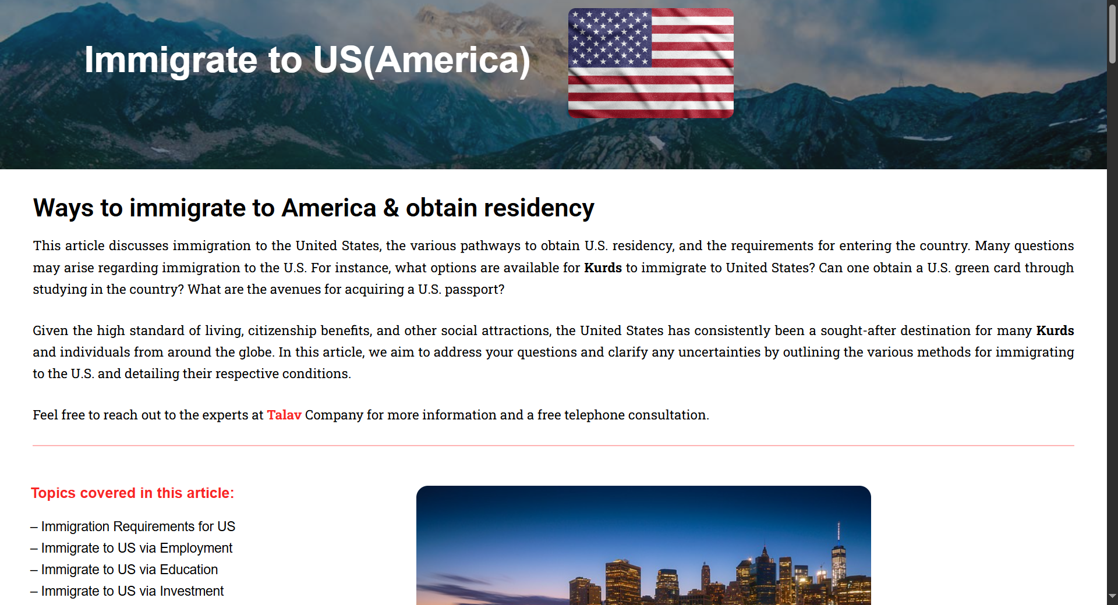

Figure Immigration page about USA

* **Study Abroad:** This section is for individuals interested in studying in foreign countries in the website we provided 8 countries (America, Britain, Canada, Australia, Germany, Netherlands, Austria & Hungary), It offers essential information about the process, including details about different types of educational institutions, degree programs, and the associated costs in various countries. (see figure 4)



Figure Study abroad page about Canada

* **Forms:** This section contains two important forms for user interaction:
  + **Talav Form:** This form allows users to provide information about their immigration goals, including if they have a specific country in mind or if they need advice on potential destinations. This helps the company provide tailored guidance on suitable options and related costs. (see figure 5)

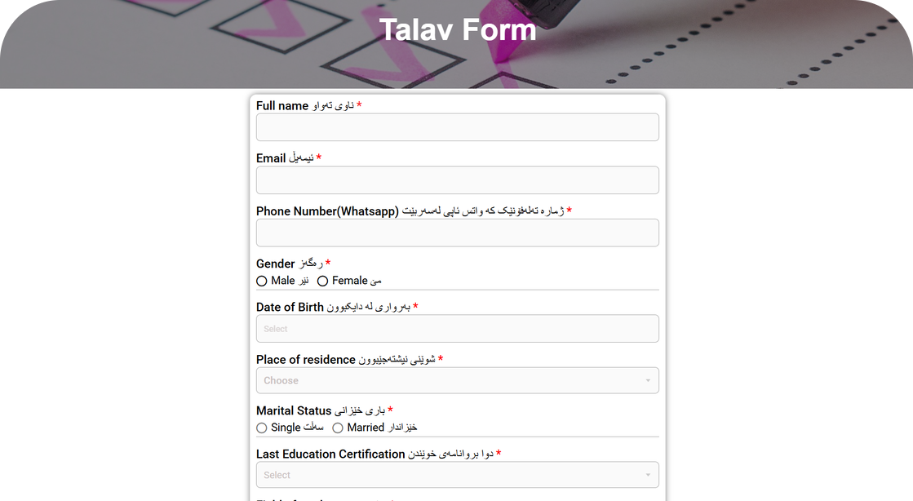

Figure Talav form

* + **Booking Form:** This form allows users to schedule a meeting at the office by selecting a date and providing their personal details such as name, email, phone number, and date of birth. (see figure 5)

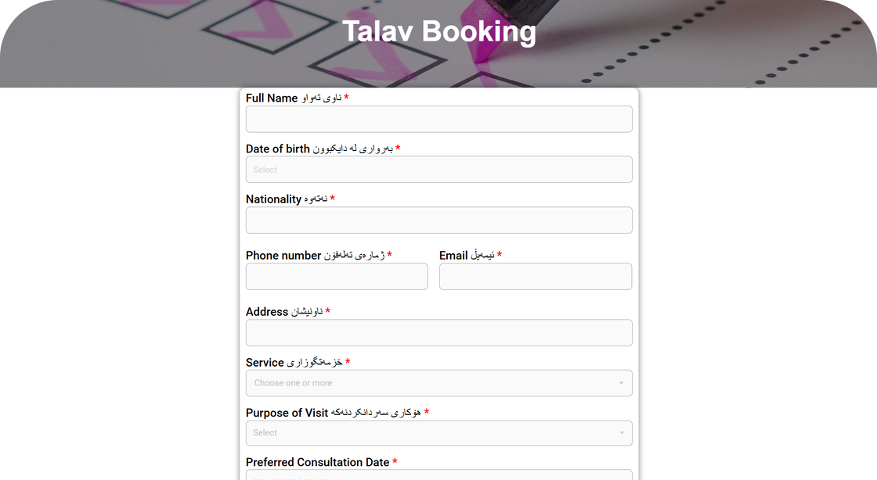

Figure Talav booking form

Both forms are available in English and Kurdish to ensure accessibility for all users. After submission, the form data is sent to the admin panel (see Figure 6).

Removed because of company’s privacy

Figure Form detail on admin panel

* **Contact Us:** This section displays the company's contact information & includes map powered by Google Maps API to show exact location of the office & some other details in below. (see figure 7)

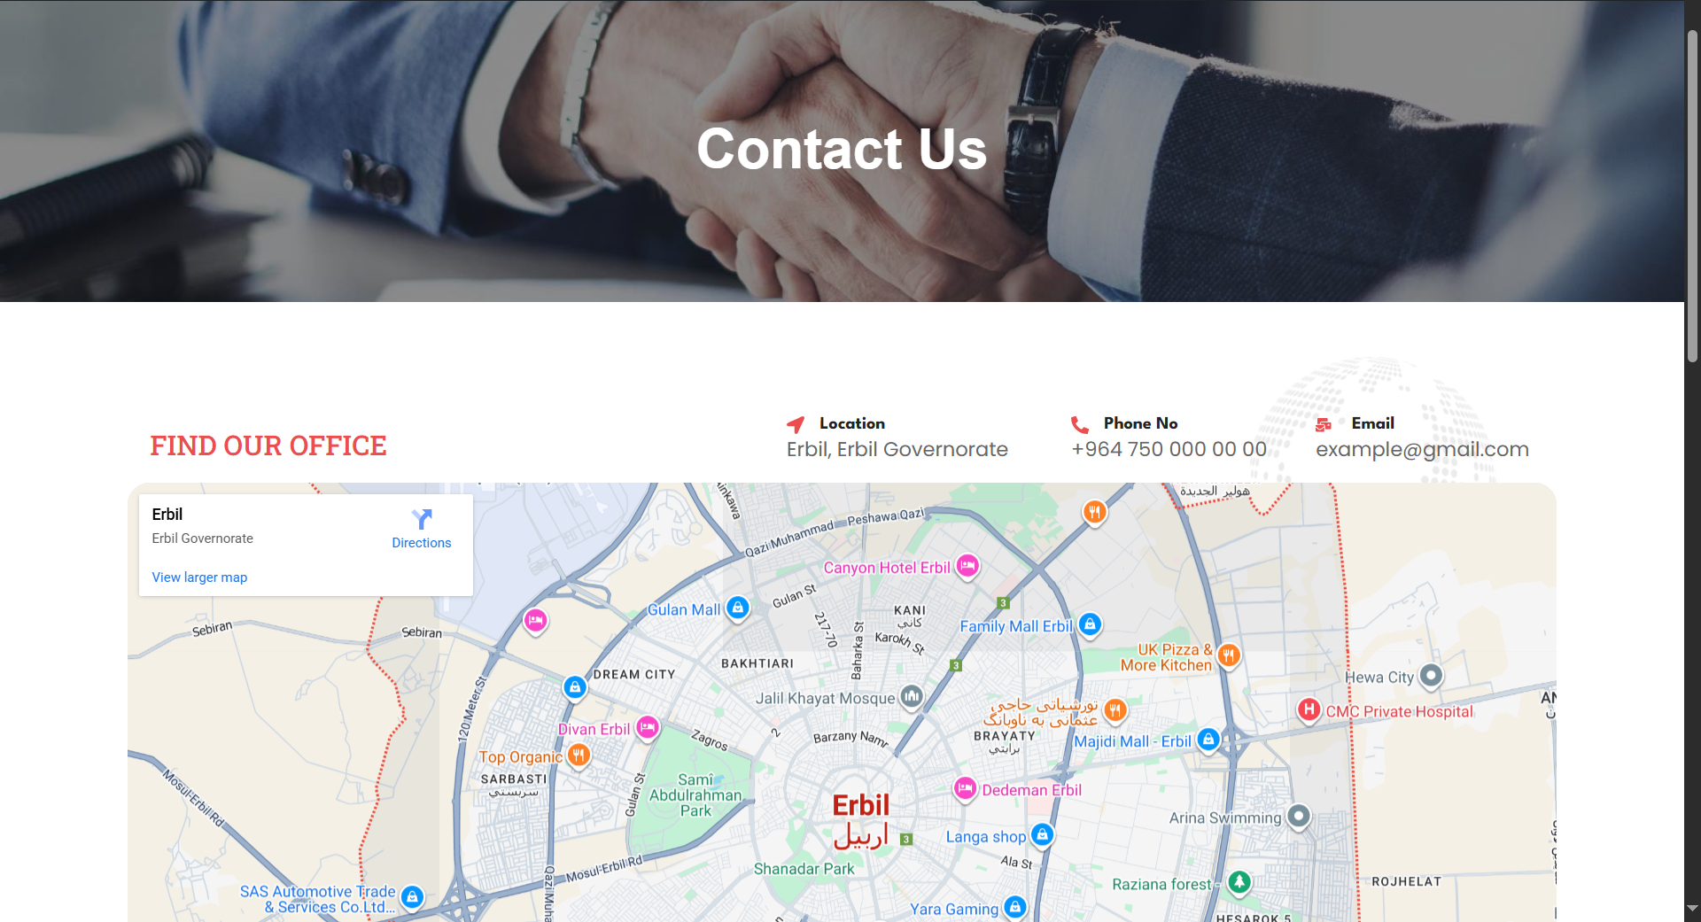

Figure Contact us page

* **About Us:** This section provides background information about the Talav immigration company, highlighting the visa consultation services offered and introducing the individuals behind the website.

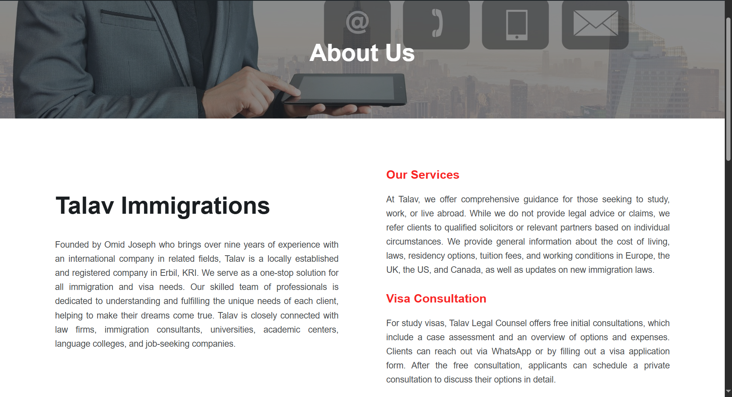

Figure About us page

* **Footer:** Located at the bottom of every page, the footer includes the company logo, contact details, links to social media profiles, and quick links to important sections of the website for easy access.

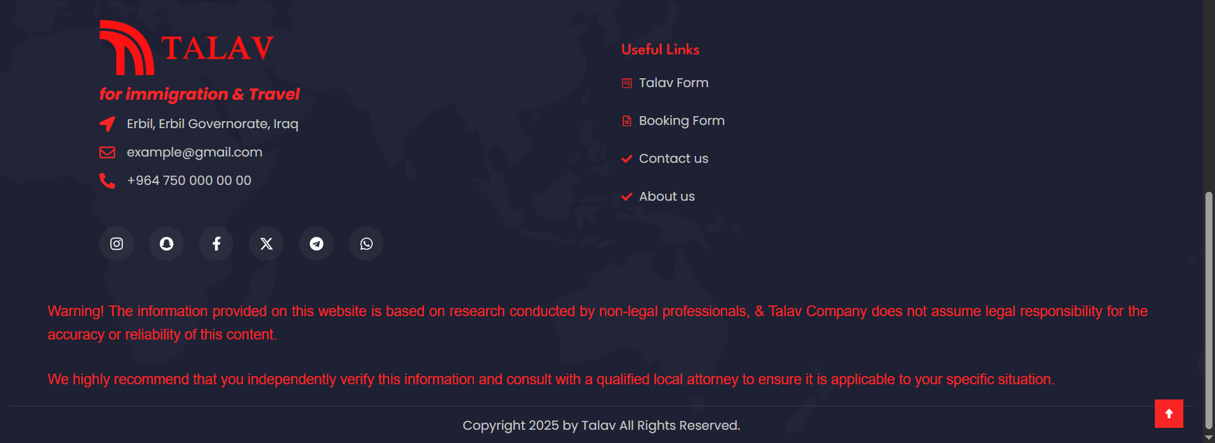

Figure Footer of website

In total, the website consists of 21 pages and includes 41 media items, such as images, to enhance the visual appeal and provide supporting content.

The careful planning and implementation using these tools and technologies by a single developer have resulted in a comprehensive and user-friendly website specifically tailored to support the immigration and study abroad aspirations of the Kurdish community.

# Chapter IV Evaluation and Discussion of the System

## 4.1 Evaluation and Discussion of the System

This chapter focuses on how well the Talav immigration platform works. We will look at how it was tested, what users think of it, and how well it performs. This evaluation will help us understand if the website meets its goals and where it can be improved. We will talk about the good things about the system and also point out any limitations.

## 4.2 Evaluation Methods

To see how well Talav immigration works, we used a few different methods:

* **Testing:** We checked all the important parts of the website to make sure they work correctly. This included things like filling out forms, and getting updates. We looked for any errors or problems that users might face.
* **User Feedback:** We asked people who used the website what they thought. This helped us understand if the platform is easy to use and if it meets their needs for travel and immigration.
* **Performance Analysis:** We looked at how quickly the website works and how well it handles many users at the same time. This helps us know if the platform is reliable.

## 4.3 Testing the System

We tested Talav immigration carefully to make sure all its features work as they should. Here are some of the things we checked:

* **Form Functionality:** We filled out the forms, to ensure they are easy to understand and submit. We also checked if the automated processes for these forms worked correctly.
* **Real-Time Updates:** We tested how quickly the website provides updates on things like changes in immigration rules or the status of applications.
* **User Interface:** We looked at how easy it is to move around the website and find what you need. We wanted to make sure the design is clear and simple to use on both computers and phones.

Our testing showed that most of the main features of Talav immigration work well. Users can generally the forms are easy to fill out. The real-time updates were also working, providing users with the latest information.

However, we did find a few minor issues. For example, a few users found some of the immigration forms a bit long, even though they were easy to understand. We made notes of these issues to fix them in future updates.

## 4.4 User Feedback

Getting feedback from people who used Talav immigration was very important. We asked them about their experience with the website, what they liked, and what they thought could be better.

Most users said they liked having everything in one place. They found it much easier to plan their travel and manage immigration tasks on Talav immigration compared to using different websites. They also appreciated the real-time updates, which helped them stay informed about important changes.

Users also mentioned that the website was easy to use and navigate. The step-by-step guidance for different processes was particularly helpful for those who were not familiar with travel booking or immigration procedures.

Some users suggested a few improvements. One suggestion was to have more detailed information for all travel options. Another was to provide more help and tips for filling out complex immigration forms. We will use this feedback to make Talav immigration even better.

## 4.5 Performance Analysis

We also looked at how well Talav immigration performs from a technical point of view. This included checking how fast the website loads and how well it handles many users at the same time.

The website generally loaded quickly, which is important for a good user experience. It was also able to handle a large number of users without slowing down, showing that it is reliable. This is thanks to the way the website was built using WordPress and efficient plugins.

However, we noted that some pages with a lot of images or information took a bit longer to load. We will work on making these pages faster to improve the overall performance of the website.

## 4.6 Discussion of Findings

Overall, the evaluation shows that Talav immigration is a useful platform for people who need to manage both travel and immigration. It meets many of its key objectives, such as providing a one-stop solution, being easy to use, and offering real-time updates.

The integration of travel and immigration services on a single platform is a major strength. Users no longer need to go to different websites for booking flights, finding accommodation, and dealing with visa applications. This saves time and reduces the stress of planning international travel.

The user-friendly design and clear guidance also make Talav immigration accessible to a wide range of users, even those who are not very familiar with online platforms or complex procedures. The use of automation for forms and processes helps to reduce errors and speeds up the overall process.

The feedback from users was mostly positive, highlighting the convenience and ease of use of the platform. The suggestions for improvement, such as more detailed information and additional help with forms, are valuable and will be considered for future updates.

While the performance of the website is generally good, there are areas where it can be improved, such as the loading speed of some pages. Addressing these technical aspects will further enhance the user experience.

## 4.7 Limitations

Despite its strengths, Talav immigration has some limitations that need to be acknowledged:

* **Scope of Services:** While the platform aims to be comprehensive, it might not cover every single travel and immigration need. Some very specific or unusual requirements might still need to be handled separately.
* **Dependence on External APIs:** The real-time updates and some other features rely on external APIs. If these APIs have issues or change, it could affect the functionality of Talav immigration.
* **Complexity of Immigration Laws:** Immigration laws are very complex and can change often. While Talav immigration tries to provide the latest information, users should always double-check with official sources for critical matters.
* **Initial Development Stage:** As a new platform, Talav immigration is still in its early stages of development. More features and improvements will be added over time based on user feedback and technological advancements.

The evaluation of Talav immigration shows that it is a promising platform that effectively combines travel and immigration services. It offers a user-friendly experience, provides real-time updates, and automates many complex processes. While there are some limitations and areas for improvement, the platform successfully addresses the challenges of fragmented services in the travel and immigration sectors. The positive user feedback and the overall performance of the system indicate that Talav immigration is a valuable tool Kurdish people.The insights gained from this evaluation will be used to guide future development and ensure that Talav immigration continues to meet the evolving needs of its users.

# Chapter V Conclusions and Future Directions

## 5.1 Conclusions and Future Directions

This chapter serves as the final point of reflection on the Talav immigration project. We will revisit the core objectives that guided its development, summarize the key findings derived from our evaluation, and articulate the overall conclusions regarding its effectiveness and potential. Furthermore, we will delve into specific and actionable suggestions for future improvements and explore promising directions for the platform's continued evolution and expansion.

## 5.2 Summary of Findings

The primary motivation behind Talav immigration was to address the fragmented and often overwhelming nature of planning international travel and navigating immigration processes. We aimed to create a unified, web-based platform accessible to individuals, particularly those from the Kurdish region, seeking opportunities abroad for travel, education, investment, or resettlement. Built on the flexible WordPress framework and enhanced with various plugins and integrations, Talav immigration sought to consolidate essential services and information into a user-friendly interface.

Our evaluation, encompassing thorough system testing, valuable user feedback, and a detailed performance analysis, yielded several significant findings. The core functionalities of the platform, including form submission, information retrieval, and real-time updates (where applicable), generally performed as intended. Users overwhelmingly appreciated the central repository of travel and immigration-related resources, highlighting the convenience of managing multiple aspects of their international endeavors within a single digital environment. The intuitive design and step-by-step guidance were particularly praised by individuals less familiar with online platforms or complex bureaucratic procedures.

However, our investigation also identified areas necessitating further attention. While the forms were generally understandable, some users perceived certain immigration-related forms as lengthy, suggesting a need for potential streamlining or enhanced user guidance during the completion process. Additionally, feedback indicated a desire for richer content across all travel and immigration options, including more nuanced details and potentially user-generated content or reviews. From a technical standpoint, while the platform demonstrated robust performance under typical load, instances of slightly prolonged loading times on content-heavy pages were noted, indicating a need for further optimization.

In essence, our findings confirm the viability and user acceptance of a consolidated platform like Talav immigration. It successfully bridges the gap between disparate travel and immigration services, offering a more streamlined and informed experience. However, the evaluation also underscores the continuous need for refinement, content enrichment, and technical optimization to fully realize its potential.

## 5.3 Conclusions

Talav immigration represents a significant stride towards simplifying the complexities associated with international travel and immigration. By centralizing essential tools and information, it effectively addresses the initial problem statement concerning the fragmented nature of existing services. The platform's user-centric design, leveraging the accessibility of WordPress and targeted plugins, has resulted in a system that is generally easy to navigate and understand, even for individuals with varying levels of technical proficiency. The incorporation of real-time updates, where feasible through API integrations, adds a layer of reliability and trustworthiness, ensuring users have access to the most current information.

The positive reception from our test users validates the core concept of Talav immigration. The convenience of managing travel bookings, exploring immigration pathways, and accessing relevant information within a single platform significantly enhances the user experience and reduces the cognitive load associated with planning international journeys. The platform's specific focus on the needs of the Kurdish community, providing information relevant to their unique circumstances, further underscores its value proposition.

Despite the acknowledged limitations, such as the inherent complexity of immigration laws and the ongoing development nature of the platform, Talav immigration has demonstrably achieved many of its key objectives. It provides a foundational one-stop solution, offers a generally user-friendly experience, and incorporates elements of real-time information delivery. The platform's success in these areas positions it as a valuable resource and a promising foundation for future growth and expansion in the digital travel and immigration landscape.

## 5.4 Suggestions for Future Improvements and Directions

Building upon the insights gained from our evaluation, the future development of Talav immigration should focus on enhancing user experience, expanding its service offerings, and ensuring long-term sustainability and relevance. The following expanded suggestions provide a more detailed roadmap for future improvements and potential directions:

* **Enhanced Content and Information Architecture:**
  + **Deeper Dive into Destinations:** Expand the information available for each destination country, including more detailed cultural insights, cost of living breakdowns, local transportation guides, and potential integration resources for newcomers.
  + **User-Generated Content:** Explore the possibility of incorporating user reviews, testimonials, and forums to foster a sense of community and provide peer-to-peer support and insights.
  + **Interactive Guides and Checklists:** Develop interactive guides and personalized checklists for various immigration and travel pathways to further simplify complex processes and ensure users don't miss crucial steps.
  + **Multilingual Content Expansion:** While the initial focus was on English and Kurdish, consider adding support for other relevant languages to broaden the platform's reach and accessibility.
* **Improved User Experience and Interface:**
  + **Form Optimization:** Analyze user interaction with forms to identify areas for simplification, potentially breaking down lengthy forms into smaller, more manageable steps with clear progress indicators.
  + **Enhanced Search and Filtering:** Implement more robust search and filtering functionalities to allow users to quickly and efficiently find the specific information relevant to their needs.
  + **Personalized Dashboards:** Develop personalized user dashboards where individuals can track their applications, saved preferences, and receive tailored recommendations based on their profiles and interests.
  + **Accessibility Enhancements:** Conduct thorough accessibility audits to ensure the platform is usable by individuals with disabilities, adhering to WCAG guidelines.
* **Service Expansion and Integration:**
  + **Partnerships with Service Providers:** Explore potential collaborations with reputable travel agencies, insurance providers, legal consultants, and settlement service organizations to offer integrated services directly through the platform.
  + **Payment Gateway Integration:** For bookable services or consultation fees, integrate secure and reliable payment gateways to facilitate transactions directly on the platform.
  + **API Integration Expansion:** Identify and integrate with additional relevant APIs to provide real-time data on flight availability, accommodation pricing, currency exchange rates, and more dynamic immigration updates.
  + **Educational Resources:** Develop a dedicated section for educational resources related to travel and immigration, such as webinars, downloadable guides, and FAQs.
* **Technical Optimization and Innovation:**
  + **Performance Optimization:** Conduct thorough performance audits and implement caching mechanisms, image optimization techniques, and efficient database management to significantly improve page loading speeds.
  + **Mobile-First Design and Native Mobile Applications:** Prioritize a mobile-first design approach to ensure responsiveness across all devices. Furthermore, explore the development of native mobile applications for iOS and Android to enhance accessibility and user convenience.
  + **AI-Powered Assistance:** Investigate the potential of integrating AI-powered chatbots or virtual assistants to provide instant support, answer common questions, and guide users through various processes.
  + **Data Analytics and Personalization:** Implement robust data analytics to understand user behavior and preferences, enabling personalized recommendations and targeted content delivery.
* **Community Building and Support:**
  + **Forums and Discussion Groups:** Create online forums or discussion groups where users can connect with each other, share experiences, and ask questions.
  + **Direct Support Channels:** Offer clear and accessible direct support channels, such as email, live chat, or phone support, to address user inquiries and provide assistance.

By strategically pursuing these future improvements and directions, Talav immigration can evolve from a promising initial platform into a comprehensive, indispensable resource for individuals navigating the complexities of international travel and immigration, particularly within the Kurdish community and potentially beyond. Continuous user engagement, technological innovation, and strategic partnerships will be crucial in realizing the full potential of Talav immigration.